**Lab 19: EXE With Trojan Code in a New Section**

**Course Name**: Malware Analysis and Reverse Engineering (IAM302)

**Student Name**: Nguyễn Trần Vinh – SE160258

**Instructor Name**: Mai Hoàng Đỉnh

**Lab Due Date**: 18/3/2023

**What You Need**

A Windows machine, real or virtual. I used a Windows Server 2008 virtual machine.

**Purpose**

To modify a Windows EXE file and save an altered version containing Trojan code in a new PE section. This gives you practice with very simple features of the Immunity debugger and LordPE

**Task 1: Add a Section with LordPE**

**Copying putty.exe**

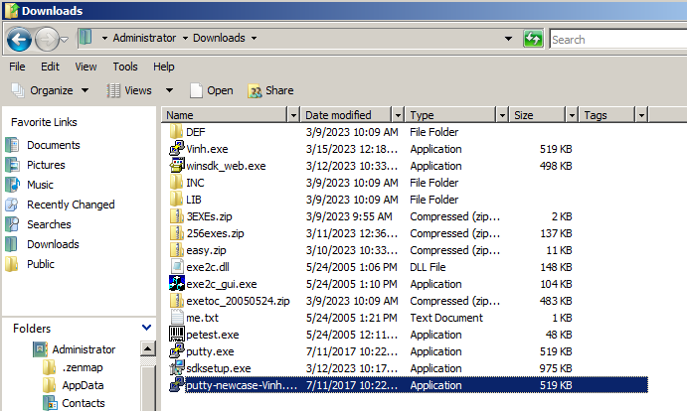

**Getting LordPE**

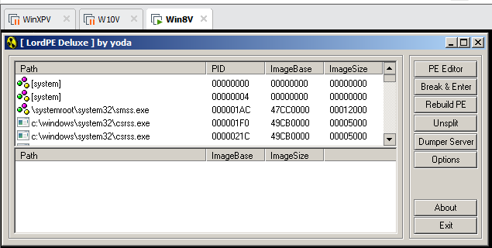

**Adding a New Section to the PE Header**

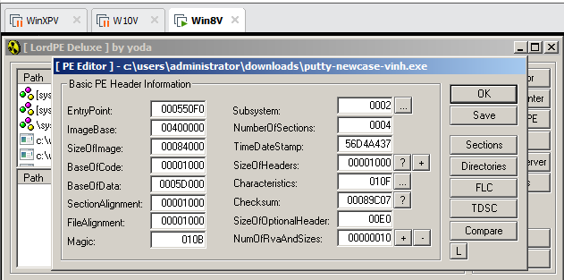 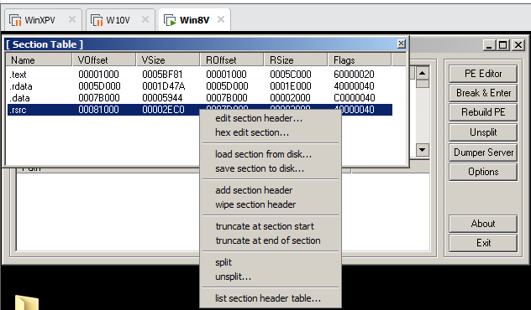 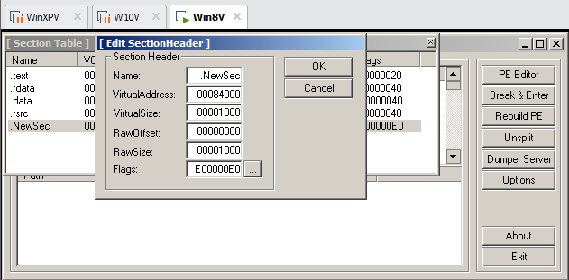 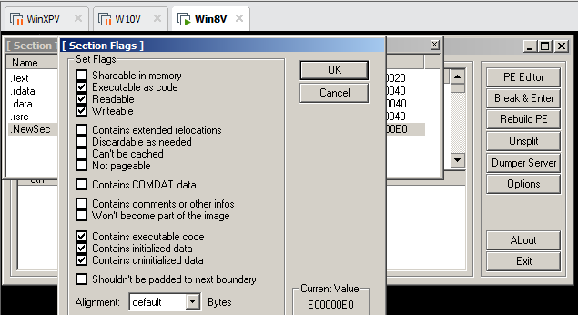

**Task 2: Redirecting Code Execution with Immunity**

**Using Immunity to Examine the NewSec Section**

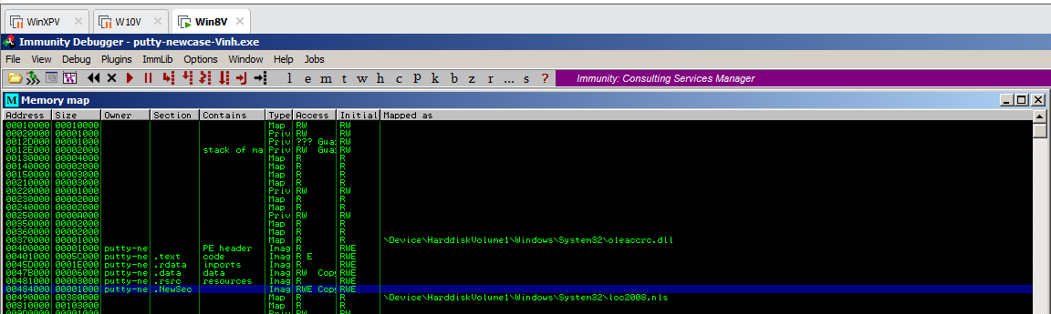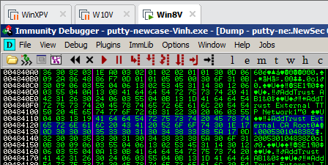

**Using Immunity to Redirect Code Execution**

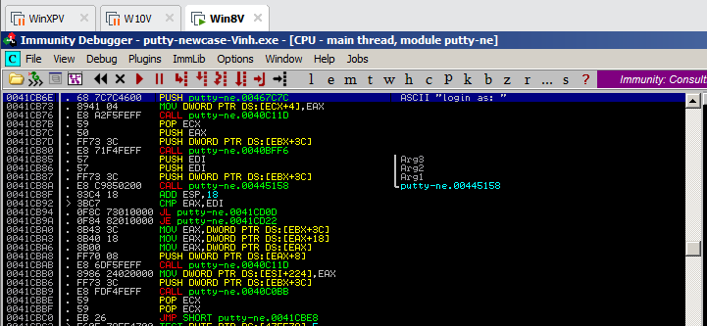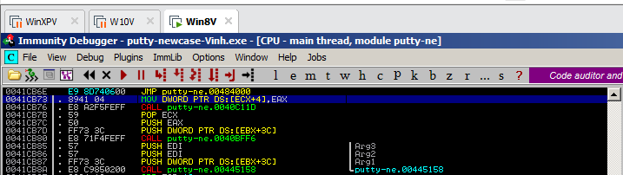

**Adding Trojan Code**

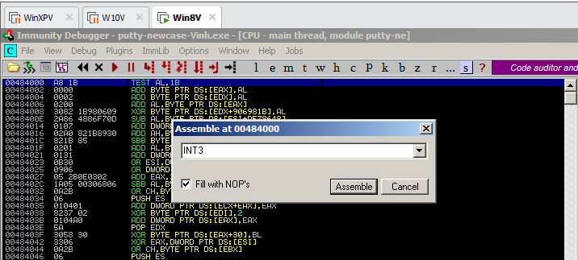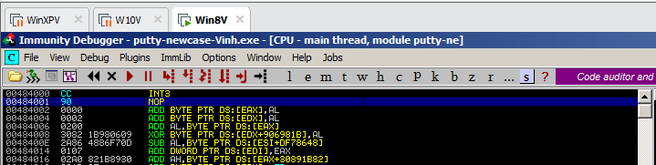

**Running the Modified App in Immunity**

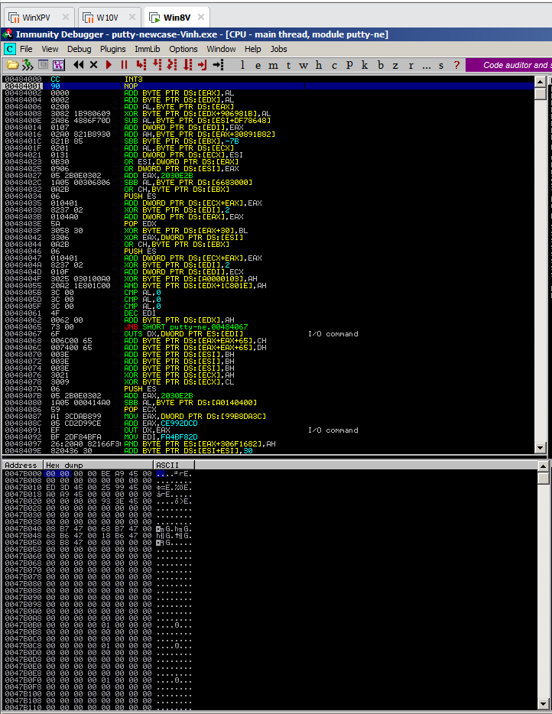

**Task 3: Inserting Real Shellcode**

**Saving the Modified EXE**

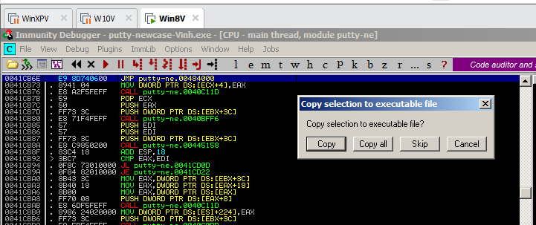

**Getting Simple Shellcode**

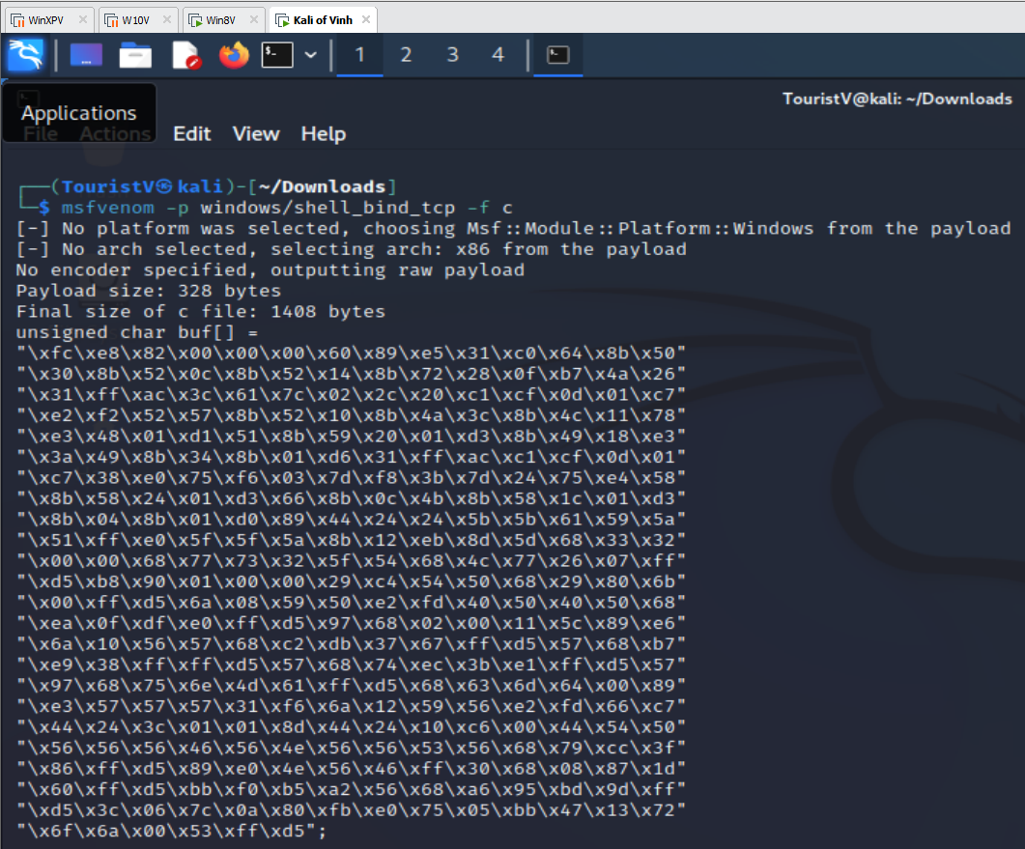

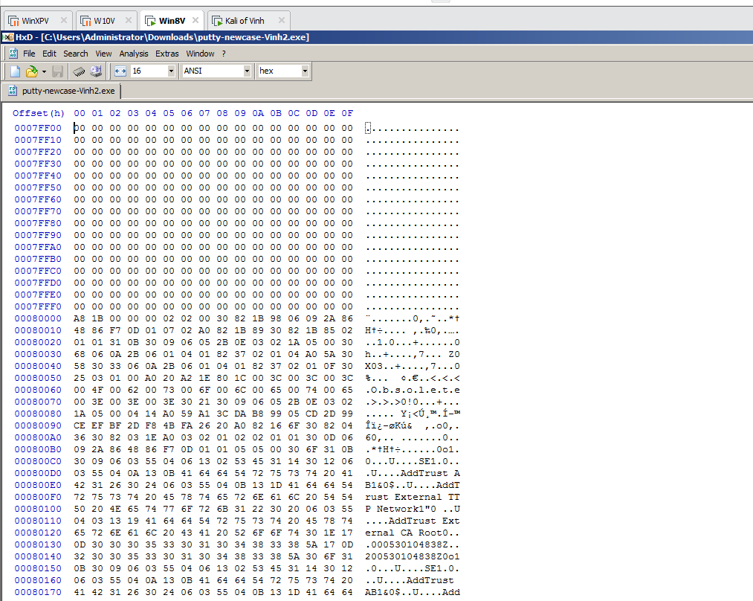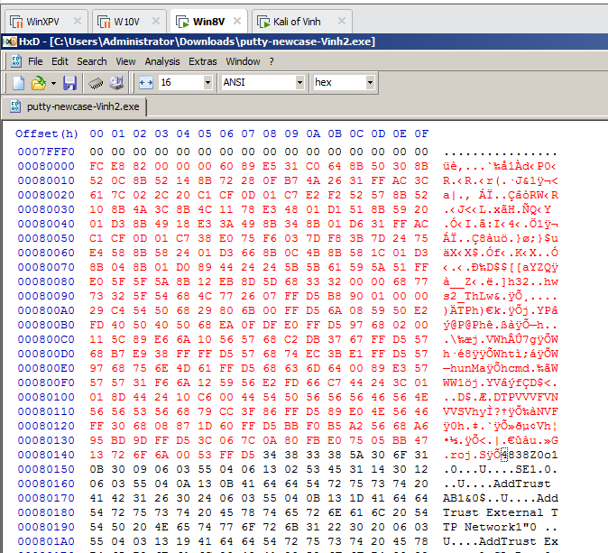

**Running the Trojaned Putty**

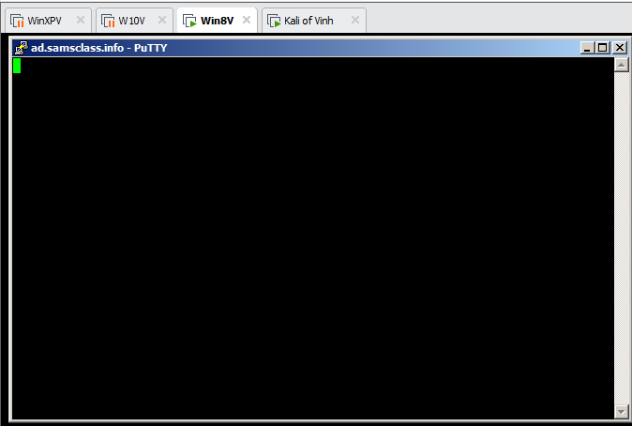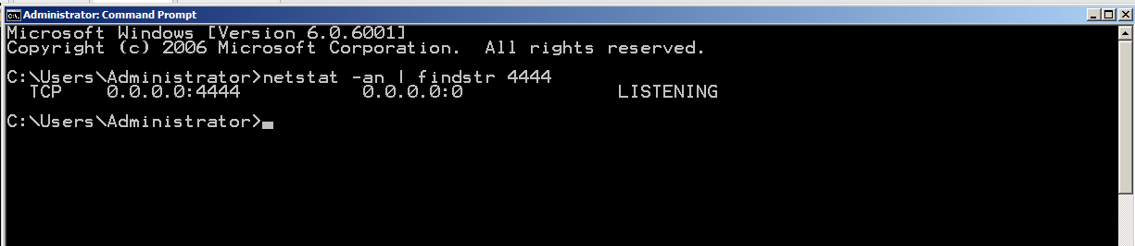

**Connecting to the Target**

